Busan Super Cup
International Yacht Race 2019
Suyeong Bay Yacht Center, Busan
2019. 5. 3 ~ 5. 5

Notice of Race
Busan Super Cup International Yacht Race 2019 is
authorized by Asia Sailing Week Organizing Committee
in conjunction with Busan Sailing Federation
sponsored by Busan Metro city, Ministry of Culture, Sports and Tourism

1 Rules

  - The regatta will be governed by the rules as defined in The Racing Rules of Sailing 2017-2020,
WS Offshore Special Regulations(OSR 2018-2019) Category 4 will apply for the Busan Super Cup Race.
1.2 If there is a conflict between languages the English text will take precedence.
1.3 If there is a conflict between NOR and SI, SI will take precedence. This changes RRS 63.7.

2 Advertising

WS Advertising Code will apply. Competitors & Boats advertising will be without restriction.
Event Advertising by the Organizing Authority will be:
- bow numbers with advertisement which have to be displayed as forward as possible on the both sides of the first 20% of the hull
- advertisement to be displayed on the both sides of the foremost 20% of the mainsail boom
- sponsor’s flag that has to be flown on the backstay throughout in harbor the entire event.
- The advertising sticker that gave from Organizing Authority have to be displayed on the center of hull

The Organizing Authority may also require the installation, at no cost to competitors, of onboard video cameras, position devices, and guest riders whose on-board positional restrictions are defined in the Sailing Instructions.

3 Eligibility
3.1. All boats participating in this regatta shall comply with the following:
a) This regatta is open to single mono hulled and self-righting and have an overall length (LOA) not less than 25 ft(8m) in the ORC and Open classes.
b) ORC class from the ship in 2019, was issued a valid ORC Club or ORC International ratings must be equipped with a certificate, NOR or SI specifically except as modified or deleted by ORC ratings system should fit all the provisions of the rule (RRS 78.1). The rating certificate is signed with the entry form shall be submitted by the Director.
※ ORC rating certificate (2019) must be issued by a participant, → www.orc.org
c) All boat is participating in the competition, must be examined safety check in accordance with the OSR category 4 and It lead you to be able to participate in the race when you are determined ‘suitable’ by the Safety Inspectors. Skippers are required to perform a self-safety inspection according to the OSR category 4 on the WS website (http://www.sailing.org/documents/offshorespecialregs/index.php) When you register for competition, ‘The Safety Inspection’ form which will be announced on the regatta official website afterward must be submitted with.
d) All boat has to put right national Sail Number on Main Sail and Spinnaker or Gennaker Sail
e) All boat has to have a Marine VHF or Satellite Phone
f) Beside, the boat was approved from OA can enter.

3.2 Eligibility of Crews for the Busan Super Cup International Yacht Race
a) The minimum number of crews including skipper on a boat should be 4 and the age must be over 16,
b) At least one member of boat must have attended WS Offshore Personal Sea Survival Course certificate or similar program of own country within the last five years before the start of the race.
c) It is strongly recommended that at least 50% of the crews on a boat shall have completed a Category 4 race or higher, or an equivalent passage.
3.3 If the Organizing Committee determines that there are safety problems or other problems, such as unsportsman-like conducts, with a boat or its members, the Organizing Committee may refuse or cancel their participation.

4 CLASSES
∙ ORC CLASS Ⅰ | ∙ ORC CLASS Ⅱ | ∙ OPEN CLASS
4.1 The race classes will be divided into 4 as follows:
4.2 The ORC classes shall be made in accordance with the GPH ratings. Efforts will be made to make each class as equal in number as possible, but if there are any boats left over after making equal, they will be assigned to the higher GPH rating class (ORC CLASSⅡ). All decisions of the classes will be made by the Organizing Committee and such decisions shall be final and not subject to any protest.
The CLASS will be confirmed by 15:00 on a day before of first races. After this point there will be no changes in the CLASS, even though there may be changes in their handicap ratings (GPH).
And the OPEN CLASSES are also divided into two classes according to same method with KSAF PHRF.

5 Entries and Entry Fee
5.1 Eligible boats may enter by Computer or Mobile on official web site Before 18:00 3rd April 2019
Official Website |  | www.busansupercup.or.kr

After making entry on official website than send e-mail (sailingbusan@gmail.com) to this follows
- PHOTO OF THE BOAT in hi-res JPEG
- a copy of VALID INSURANCE (water leisure activity general or third-party liability)
- WS OSR Safety INSPECTION CARD
- REGISTRATION CERTIFICATE of the Boat on Own Country
- Current ORC CERTIFICATE (Only for ORC Class)

5.2 The non-refundable entry fee should be paying by credit card through the official website or mobile , and bank transferred to
Account Name | Busan Sailing Federation, |  |  | Bank(Branch) Name | Busan Bank  (Marine City)
Account Number | 101-2053-0767-08 |  |  | Bank(Branch)  Code | 0321718
 |  |  |  | Swift code | PUSBKR2PXXX,
Fee for  a boat | Before  The date | Less than 40ft | 200.00 USD | Fee for  members | Before  The date | 30.00 USD
 |  | 40ft and over | 250.00 USD
 | Late entry | Less than 40ft | 250.00 USD |  | Late  entry | 35.00 USD
 |  | 40ft and over | 300.00 USD
Total amount of entry fee is the sum of fee per boat plus all members (skipper+crews )fee.
5.3 The organizer is not responsible for any costs incurred by the non-acceptance of a boat’s registration.
5.4 The allowance of additional entry after the above period for entry will be determined by Organizing Authority.
5.5 The race committee can limit the number of entries even before the entry closing day by the reason of the reasonable boats numbers and effective progress of race

6 Registration and Schedule
6.1 Each Owner or Skipper must personally register in the Race Office located in Busan Yachting Center Marina at organizer’s office (Busan Sailing Federation).

Date | Time
3rd May (FRI) | 09:00 ~ 18:00

6.2 The following documents shall be presented at registration:
- All Crew list with name, surname, date of birth, Copy of Passport
- CERTIFICATION of Safety Training Program of participant’s own country
6.3 Crew lists may be amended up to 3rd May 2019 at 09:00 by filling a new form showing the changes. After this time, changes in crew may be made only with the written permission of the International Jury.
6.4 It is ok to have less crews in your boat than you have register to participate at the race. However, it is not allow to have more crews on the boat after the registration(The minimum number of crews must be keep.)

Date | Schedule | Time |  | Venue
2nd May  (THU) | Registration And Measurement |  | 13:00 ~ 18:00 | O.A
3th May  (FRI) | Registration And Measurement |  | 09:00 ~ 18:00 | O.A
4th May  (SAT) | Skipper Meeting |  | 09:00 ~ | Front of O.A building
 | Inshore races |  | 11:00~ | Race Area
 | Opening Ceremony |  | 18:00~
5th May  (SUN) | Skipper Meeting |  | 08:30 ~ | Front of O.A building
 | Inshore races |  | 10:00 ~ | Race Area
 | Prize giving |  | 17:00 ~ 19:00 | Front of O.A building
6.5

6.6 On the last scheduled day of racing no warning signal will be made after 14:00.

7 Measurement
All the boat that is participating in the competition must do a boat measurement as it goes around randomly by Organizing Authority.

8 Sailing Instructions
Sailing Instructions will be available for each entrant at completion of the registration formalities at the venue.

9 Venue
Attachment 1. shows the location of the racing areas.

10 The Courses
The courses to be sailed will be in the Attachment 2.

11 Penalty System
RRS 44.1 is changed so that the Two-Turns Penalty is replaced by the One-Turn Penalty.

12 Scoring
A boat’s series score will be the total of her race scores.
12.1 Scoring shall be applied to RRS Appendix A3. .
12.2 Race results are computed according to the ORC rules and fixed time PHRF.
12.3 PHRF rating is determined by the official measurer of Organizing Committee , this is not the subject of the protest. This changes RRS 61

13 International Jury
An international jury has been appointed in accordance with rule 91(b), its decisions will be final as provided in RRS 70.5.

14 Nautical charts
The following nautical charts of the Korea Hydrographical and Oceanographic Administration are utilized as a reference in the Sailing Instructions: K-2131, K-2153. Please refer to www.chartkorea.com for availability.

15 Moorings
Free allocated berthing will be provided from 12:00 26th April to 14:00 12th May at Busan Yachting Center Marina in front of organizer’s office.

16 HAUL-OUT Restrictions
Boats shall not be hauled out during the regatta except with and according to the terms of prior written permission of the race committee

17 Registration of arrival
17.1 CIQ procedure shall be supported by the organizer to boats arrived from 26th April.
17.2 Following documents shall be provided before arriving at the Event Venue for CIQ procedure.
a) Registration Certificate of Ship’s Nationality
b) Ship Sanitation Control Exemption Certificate/Ship Sanitation Control Certificate
c) Crew list (It should include Date of birth, Sex, Passport number in case of person who arriving Korea by boat)
17.3 Other information for CIQ shall be found at the organizer’s homepage.

18 Media rights
Competitors, owners and their guests give absolute right and permission to the Organizing Authority for any photography and video footage taken of persons and boats during the event, to be published and/or broadcasted in any media, including but not limited to TV advertisements, whatsoever for either editorial or advertising purposes or to be used in press information.

19 Communication
Except when communicating with the Race Commitee, a boat while racing, shall not transmit or receive communication of any information not publicly available to all boats participating.

20 Trophies and Prizes
The SuperCup Champion Trophy will be awarded to the winner of ORC class and Super Cup trophies will be awarded to ranked boats from 1st to 3rd.
Prizes will be given as follows
 | ORCⅠ | ORCⅡ | OPEN
1st | EXECUTORY | EXECUTORY | EXECUTORY
2nd
3rd
4th
5th
※ There can be changed on the amount of prize money in case of confirmation of execution plan.

21 Disclaimer of Liability

All those taking part in the regatta do so at their own risk and responsibility. The Organizing Authority, Busan Sailing Federation, Korean Sailing Federation, ORC and any other party involved in the organization of the Busan Supercup International Yacht Race disclaim any and all responsibility whatsoever for loss, damage injury or inconvenience that might occur to persons and materials, both ashore and at sea as a consequence of participation in the event. Each boat owner or his representative accepts these terms by signing entry form. The attention of competitors is drawn to WS Part 1 Fundamental Rule 4: A boat is solely responsible for deciding whether or not to start or to continue racing.

22 Participation Subsidy
22.1 Participation subsidy will be provided according to each boat’s sailing distance to the venue as follows
Distance | Amount
Less than 20miles | EXECUTORY
Over 20miles
Over 50mies
Over 100miles -
Overseas (Japanese, Russian, Chinese , ect.)
※ The amount of subsidy for foreign boats mooring at domestic harbor is same as Korean boats

22.2 Every yacht which at the time of departing a Korean home port has to submit a copy of the notice for
’ long distance water activity report’ which is notice to Korea Coast Guard on departure to the race committee for the registration.
22.3 For those boats for which the Organizing Committee has refused their participation or for those not completing the races (such as withdrawing from a race during the event with no reason) for reasons which do not justifiably convince the Race Committee, the subsidies for the voyage and parade participation will not be paid.

23 Insurance

Each participating boat shall be insured with valid third-party insurance. Regardless, it is the responsibility of the owners to hold adequate insurance cover for Tort and Third Party Insurance (Property and Persons).

24 Further information
For further information please contact sailingbusan@gmail.com / +82-51-747-1982 (Phone)
※ Local accommodation information is provided at Haeundae-gu Office Homepage: eng.haeundae.go.kr

ATTACHEMENT 1. RACE AREA
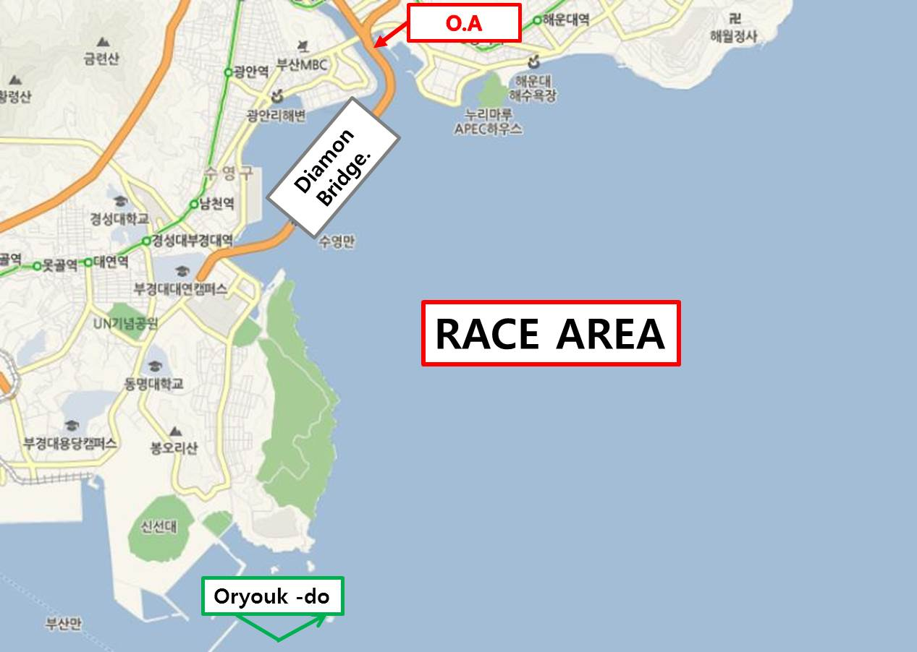

ATTACHEMENT 2.
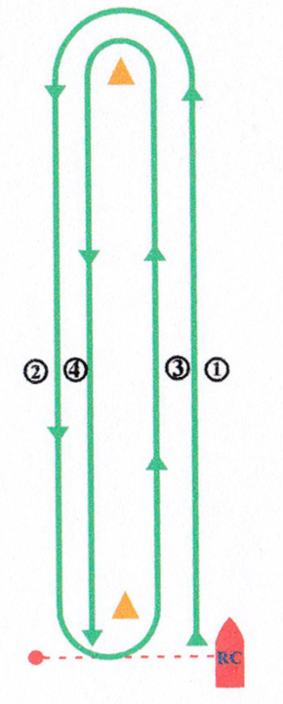

windward – leeward course
※It can be change

ATTACHEMENT 3.
2018-19 WS OSR SAFETY INSPECTION CARD
CATEGORY 4 / Monohull |  |  |  |  |  |  | Short races, close to shore in relatively warm or protected waters normally held in daylight
DATE OF SUBMIT |  |  |  |  |  | SAIL NO |  |  |  |  |  |  |  |  | YACHT NAME
/ /
YACHT DETAILS
LOA (ft) |  |  |  |  |  |  |  |  |  |  |  |  |  |  |  | Hull Color
DISP (tons) |  |  |  |  |  |  |  |  |  |  |  |  |  |  |  | Deck Color
Hull Material |  |  |  | □ FRP □ CRP □ AL □ Wood □ Steel, etc( ) |  |  |  |  |  |  |  |  |  |  |  | Builder
Deck Material |  |  |  | □ FRP □ CRP □ AL □ Wood □ Steel, etc( ) |  |  |  |  |  |  |  |  |  |  |  | Model
Max Crew |  |  |  | prns | Liferaft Capacity |  |  |  |  | prns |  |  |  |  |  | Remarks
PERSONS IN CHARGE DETAILS
PIC name |  |  |  |  |  |  |  |  |  |  |  |  |  |  |  |  | Club/Affiliation
associate PIC |  |  |  |  |  |  |  |  |  |  |  |  |  |  |  |  | Skipper
DECLARATION BY PERSON IN CHARGE
- The safety of a yacht and her crew is the sole and inescapable responsibility of the person in charge who must do his best to ensure that the yacht is fully found, thoroughly seaworthy and manned by an experienced crew who have undergone appropriate training and are physically fit to face bad weather. He must be satisfied as to the soundness of hull, spars, rigging, sails and all gear. He must ensure that all safety equipment is properly maintained and stowed and that the crew know where it is kept and how it is to be used. He shall also nominate a person to take over the responsibilities of the Person in charge in the event of his incapacitation.
- Decision to race - The responsibility for a yacht's decision to participate in a race or to continue racing is hers alone - RRS Fundamental Rule 4.
- Inspection is carried out only as a guide. An inspector cannot limit or reduce the complete and unlimited responsibility of the owner and the person in charge.
- I undertake that all of the boat's equipment as specified in the Offshore Special Regulations 2016-17 will remain on the boat and continue to be in good working order and repair for the duration of each and every race.

I have read and understand my obligations as Person in Charge set out in the WS Offshore Special Regulations 2014-15, in particular 1.02.1, 1.02.2, 1.02.3 Owner’s Responsibility, and 2.03 General Requirements. I understand that this inspection is carried out only as a guide to Persons in Charge and Race Organizing Authorities.
 |  |  |  |  |  |  |  |  |  |  |  | Signed by Person in Charge
EQUIPMENT/STATUS CHECK |  |  |  |  |  |  |  |  |  |  |  |  |  |  |  |  | Please mark each item with a tick or cross in the PIC’s check box
No | Equipment / Status |  |  |  |  |  |  |  |  |  | PIC’s  Check |  | Inspect | No |  |  |  | Equipment / Status |  |  |  |  |  | PIC’s  Check | Inspect
1 | Liferaft complied with OSR 4.20 |  |  |  |  |  |  |  |  |  |  |  |  | 21 |  |  |  | Magnetic compass independent of any power supply
2 | Life jackets 1 per crew |  |  |  |  |  |  |  |  |  |  |  |  | 22 |  |  |  | 2 red parachute flares, SOLAS
3 | Safety harness 1 per crew |  |  |  |  |  |  |  |  |  |  |  |  | 23 |  |  |  | 2 red hand flares, SOLAS
4 | - with whistle, retro-reflective material, flashlights, strobe |  |  |  |  |  |  |  |  |  |  |  |  | 24 |  |  |  | 2 orange smoke flares, SOLAS
5 | - with a mid-point snap hook on a 2m safety line |  |  |  |  |  |  |  |  |  |  |  |  | 25 |  |  |  | A separate battery for starting the engine
6 | - static safety lines at work stations or jack stays rigged |  |  |  |  |  |  |  |  |  |  |  |  | 26 |  |  |  | Minimum amount of fuel for duration 8 hours (20 liters)
7 | 1 anchor with chain and rope |  |  |  |  |  |  |  |  |  |  |  |  | 27 |  |  |  | 20 liters of drinking water in separated sealed containers
8 | First aid manual and first aid kit |  |  |  |  |  |  |  |  |  |  |  |  | 28 |  |  |  | Life sling(or buoy) with a whistle, a self-igniting light
9 | Tools and spare parts |  |  |  |  |  |  |  |  |  |  |  |  | 29 |  |  |  | Radar reflector at least 4.0m above the water
10 | Standing rigging cutter |  |  |  |  |  |  |  |  |  |  |  |  | 30 |  |  |  | Plugs fitting for every through-hull opening
11 | Flashlight and spare batteries and bulbs |  |  |  |  |  |  |  |  |  |  |  |  | 31 |  |  |  | Navigation lights not masked by sails or boat heeling
12 | Hi-powered flashlight/spotlight, appropriate spares |  |  |  |  |  |  |  |  |  |  |  |  | 32 |  |  |  | Reserve navigation lights and spare bulbs
13 | 1 stout bucket |  |  |  |  |  |  |  |  |  |  |  |  | 33 |  |  |  | A manual bilge pump with handle
14 | 2 fire extinguishers |  |  |  |  |  |  |  |  |  |  |  |  | 34 |  |  |  | Equipment for steering without the rudder
15 | Foghorn |  |  |  |  |  |  |  |  |  |  |  |  | 35 |  |  |  | Rig the storm jib or heavy weather jib ready for use
16 | Printed the yacht's name on all buoyant equipments |  |  |  |  |  |  |  |  |  |  |  |  | 36 |  |  |  | Rig the trysail with sheets ready for use
17 | marine VHF transceiver output power of 25W |  |  |  |  |  |  |  |  |  |  |  |  | 37 |  |  |  | Block companionway hatch shut
18 | Navigational charts, light list and chart plotting equipment |  |  |  |  |  |  |  |  |  |  |  |  | 38 |  |  |  | Heavy movable objects securely fastened in place
19 | Electronic navigation system or personal GPS |  |  |  |  |  |  |  |  |  |  |  |  | 39 |  |  |  | Lifelines taut and complied with OSR 3.14
20 | 406MHz EPIRB with water and manually activated |  |  |  |  |  |  |  |  |  |  |  |  | 40 |  |  |  | Keel stepped mast; heel securely fastened
INSPECTOR’S REPORT
Date |  | / / |  |  |  |  |  | Location |  |  |  |  |  |  |  |  |  |  | Inspector |  |  | (signed)
REPORT TO RACE COMMITTEE

